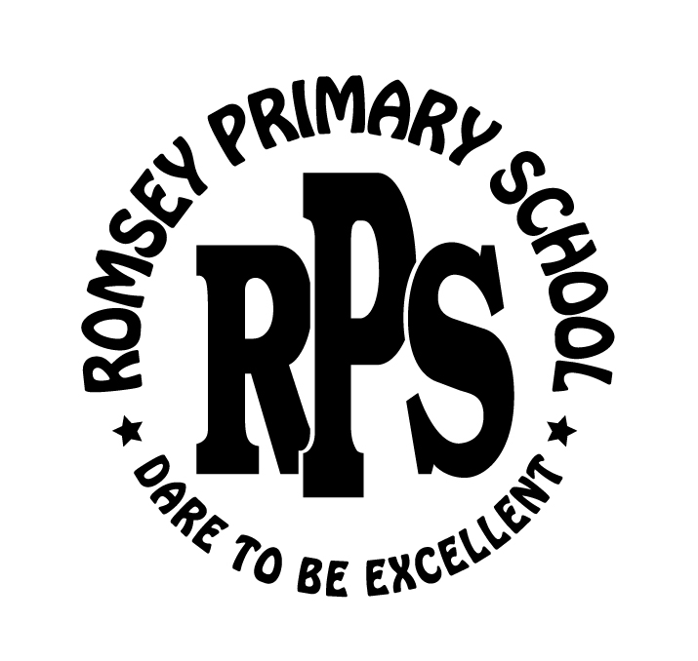 | ROMSEY PRIMARY SCHOOL  STUDENT BEHAVIOUR MANAGEMENT POLICY

Policy Statement:

The Charter of Human Rights and Responsibilities Act (2006) outline a vision of human rights for all Victorians. The charter affirms that all people are born free and equal in dignity and rights. While the charter demands equality for all, it also emphasises the value of difference. The charter requires public authorities, including government schools and their employees to act compatibly with human rights and to consider them when making decisions and delivering services. The Act (2006) prohibits the use of corporal punishment in any Victorian school. We do not permit corporal punishment at Romsey Primary School.
Rationale:

Positive and responsible student behaviour is essential to the smooth running of the school, to the achievement of optimal learning opportunities and to the development of a supportive and cooperative school environment.

Aims:

• To build a school environment based on positive behaviour, mutual respect and cooperation.
• To manage poor behaviour in a positive and professional manner.
- To establish well understood and logical consequences for student behaviour.

Implementation:
- The discipline policy will fall within Government guidelines
- The ethos of our school is to enhance positive behaviour and respect for others.
- Children are encouraged to learn to accept responsibility for their own behaviour.
- Positive student behaviour and achievement will be appropriately recognised.
- We will provide a wide range of positive extra-curricula activities for students including sporting, theatrical, leadership, community service and appropriate leisure pursuits.
- All staff will undertake professional development on student behaviour and discipline management.
- The school curriculum will include units on resilience, peer pressure, positive choices, bullying, conflict resolution and leadership.
- Staff will teach and encourage children to communicate their needs and wishes to each other and their teachers and to negotiate these whenever possible.
- Classroom and school rules will be discussed at the commencement of the school year within the classroom and specialist areas and also revised throughout the year.
- Students experiencing difficulty achieving positive behavioural outcomes will undertake individualised behaviour management programs focussing upon agreed goals.
- Consequences for ongoing inappropriate behaviour will involve a graded series of sanctions including counselling, withdrawal, and loss of privileges or suspension.
- Parents will be kept informed and actively encouraged to assist in the development of their children’s behavioural performance.
- Parents will be made aware of school rules and expectations.
- Staff members will be kept abreast of current trends in discipline and welfare issues.

School Program:

- All school discipline shall be carried out within the DET Student Engagement Guidelines (Effective Schools are Engaging schools: Student Engagement Policy Guidelines.)
- A coordinated program of discipline and welfare will be established, adopting a whole school approach that focuses on prevention and early intervention. The student welfare coordinator and Discipline & Welfare Committee will responsible for coordination of the Discipline/Welfare Program including the implementation of School Wide Positive Behaviours and Clear consequences for behaviour.

The Principal’s role:

The principal will:
- Be responsible for providing the financial and human resources for welfare and discipline support.
- Ensure details of school rules are published and well-circulated throughout the school community.
- Ensure staff are encouraged to attend professional learning relevant to discipline and welfare issues and report back to the whole staff.

LINKS & APPENDICES (including processes related to this policy)

Links connected to this policy:

- http://www.education.vic.gov.au/healthwellbeing/wellbeing/engagement/default.htm
- http://www.education.vic.gov.au/healthwellbeing/safety/default.htm
- http://www.education.vic.gov.au/healthwellbeing/safety/bullying/default.htm
- http://www.education.vic.gov.au/healthwellbeing/safety/bullying/policy.htm

Evaluation:

This policy will be reviewed as part of the school’s three-year review.

Date Ratified by School Council: October 2017

Review Date: October 2020

